**Practical no. 4**

**FS19CO042**

**Aim:** Install Network interface card and locate MAC address of computer

**Required tools/components:** PC with an empty PCI slot, Network Interface Card (NIC), Screw drivers

**Theory and steps:**

* **Network Interface Card (NIC)**

A network interface card (NIC) is a hardware component without which a computer cannot be connected over a network. It is a circuit board installed in a computer that provides a dedicated network connection to the computer. It is also called network interface controller, network adapter or LAN adapter.

Every NIC card has a speed rating in terms of Mbps which determines max bandwidth.

Each NIC card has a unique unchangeable MAC addresses also known as physical network address.

Purpose:

* NIC allows both wired and wireless communications.
* NIC allows communications between computers connected via local area network (LAN) as well as communications over large-scale network through Internet Protocol (IP).
* NIC is both a physical layer and a data link layer device, i.e. it provides the necessary hardware circuitry so that the physical layer processes and some data link layer processes can run on it.

Types of NIC cards:

* **Wireless** - These are NICs that use an [antenna](https://searchmobilecomputing.techtarget.com/definition/antenna) to provide wireless reception through [radio frequency](https://searchnetworking.techtarget.com/definition/radio-frequency) waves. Wireless NICs are designed for Wi-Fi connection.
* **Wired** - These are NICs that have input jacks made for cables. The most popular wired LAN technology is Ethernet.
* **USB** - These are NICs that provide network connections through a device plugged into the USB port.
* **Fiber optics** - These are expensive and more complex NICs that are used as a high-speed support system for network traffic handling on server computers. This could also be accomplished by combining multiple NICs.

**Image:**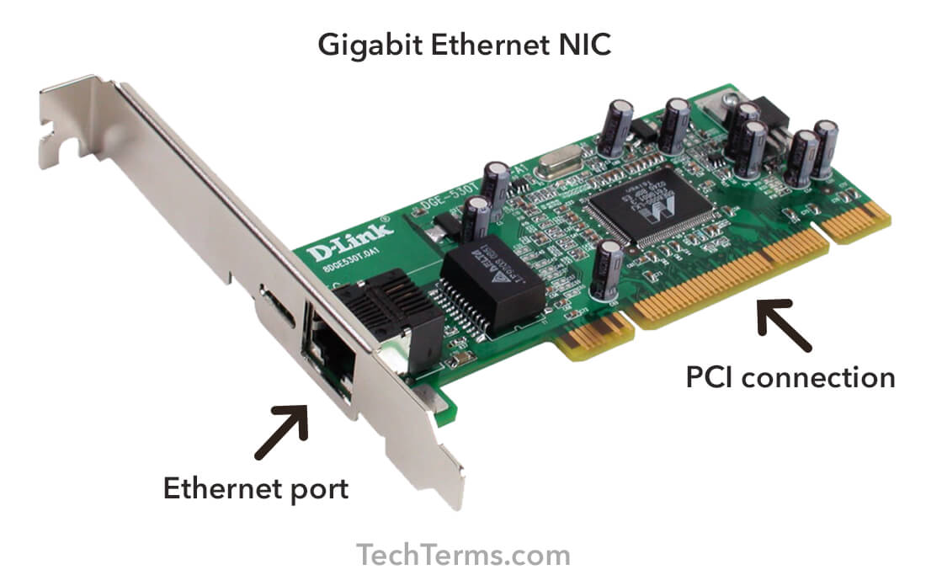

* **Installation process of Network Interface Card**
* Read specifications of NIC and get acquainted with user guide available with NIC.
* Power off the PC, remove power cord and avoid any static charge.
* 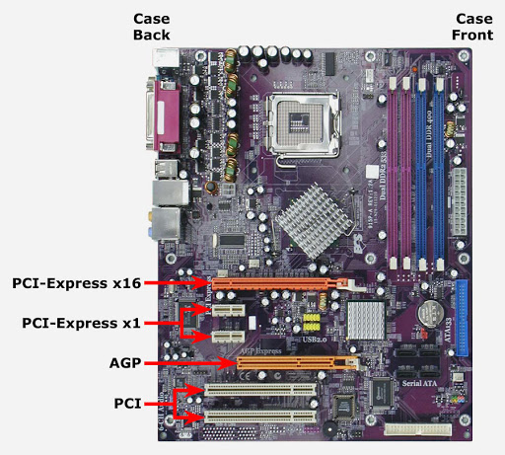Remove side panel of PC case to expose motherboard so that PCI slots on motherboard are easily accessible.
* 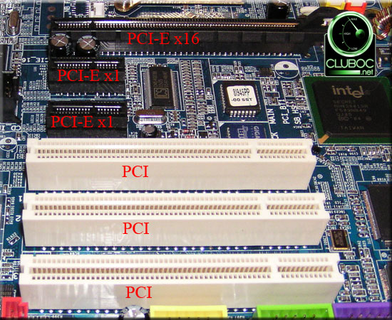Ensure that there is at least one empty PCI slot and remove any slot insert if pre-installed.
* Carefully remove the network card from its static-proof plastic envelope, and slide it into the slot.
* 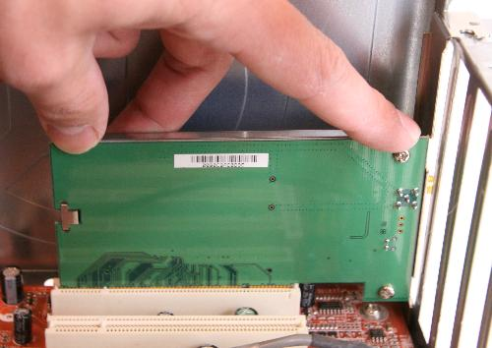Seat the card in the slot firmly with gentle pressure along the length of the card, especially right about the slot itself.
* Screw the card to computer frame avoiding overtightening.
* Close the computer case and connect ethernet cable to slot available on NIC.
* Plug PC and power it on. Go to Device manager and install appropriate drivers for the make and model of NIC.   
  Troubleshoot the drivers and ensure the source is from a trusted supplier.
* Enjoy surfing the internet
* **Locate the MAC address of computer.**

Every legit NIC card has a unique and immutable MAC address allocated by IEEE (Institute of Electrical and Electronics Engineers) giving every device a unique identity.

Steps to locate your PC’s MAC address. (Windows OS demonstration)

* 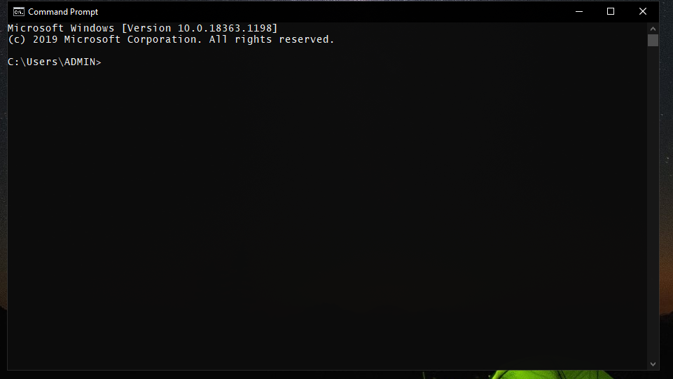Start your PC or laptop and open Command prompt or Windows Powershell.
* Type in the following command: **ipconfig /all** press enter.  
  Details of all network adapters/NICs will be displayed including their MAC address as physical address.

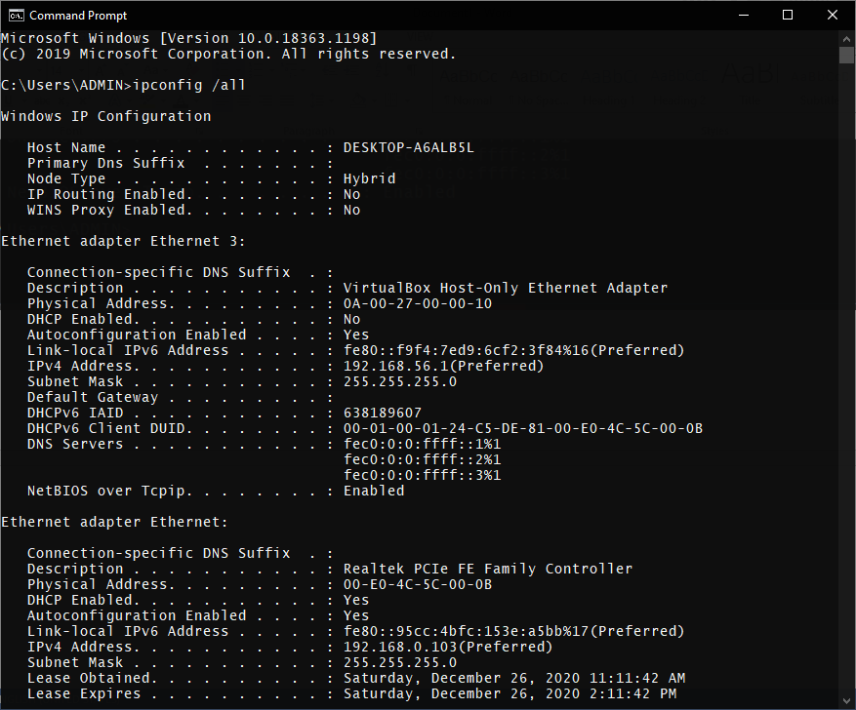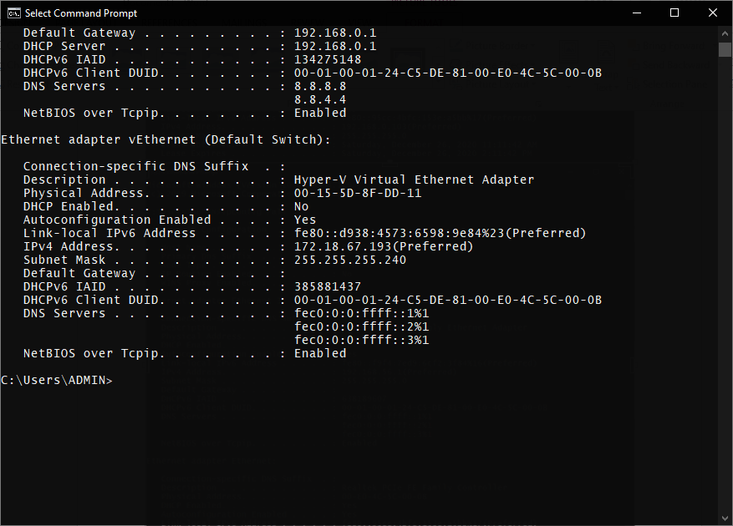

**Conclusion:** Thus we installed NIC card and located MAC address on computer.